Substituting V = IR or I = V/R gives two additional formulae:
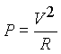
With a V/t graph, the P = V ²/R formula provides the most convenient method for calculating the power at any instant:
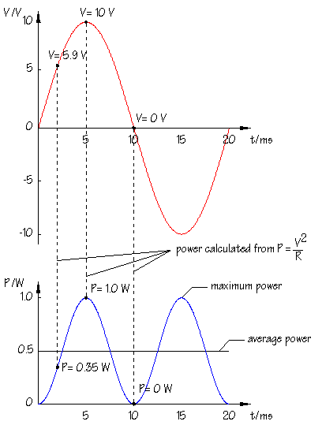
The upper graph shows an AC signal with 10V peak amplitude. This is the AC power supply illuminating a lamp:
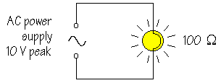
Assuming that the resistance of the lamp remains constant, R = 100 , it follows that the power developed will be different at different times during each cycle. Since V is changing, P will be changing also. For example, at t = 2 ms on the graph, V = 5.9 V and P = V ²/R = 0.35 W. At t = 5 ms, V = 10 V and P = V ²/R = 1.0 W, while at t = 10 ms, V = 0 and P = 0 V and V ²/R = 0 W.
Calculating a P value for every moment in the cycle gives the lower graph in the diagram. This is how the power produced varies during each cycle.
The apparent brightness of the lamp does not depend on the power developed at any instant, but upon the average power. Look again at the P/t graph. You can see that the average power is equal to half the maximum power.
The average power, P_{av} is therefore given by:
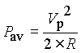
where V_{p} is the peak amplitude
Now, reverse the process and think about the DC voltage, V_{DC} which would deliver the same average power:
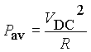
Combining these two formulae:
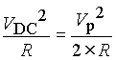
rearranging:
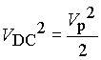
taking the square root of each side gives:
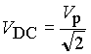
In other words, V_{DC} = V_{rms} as already defined.
It is now possible to explain that the rms value is the square root of the mean, or average, of the square of the voltages during a complete cycle of the AC signal.

